Rhino ForkliftNew
Instruction for Use
Version: V1.1.2
Date: July 24, 2025

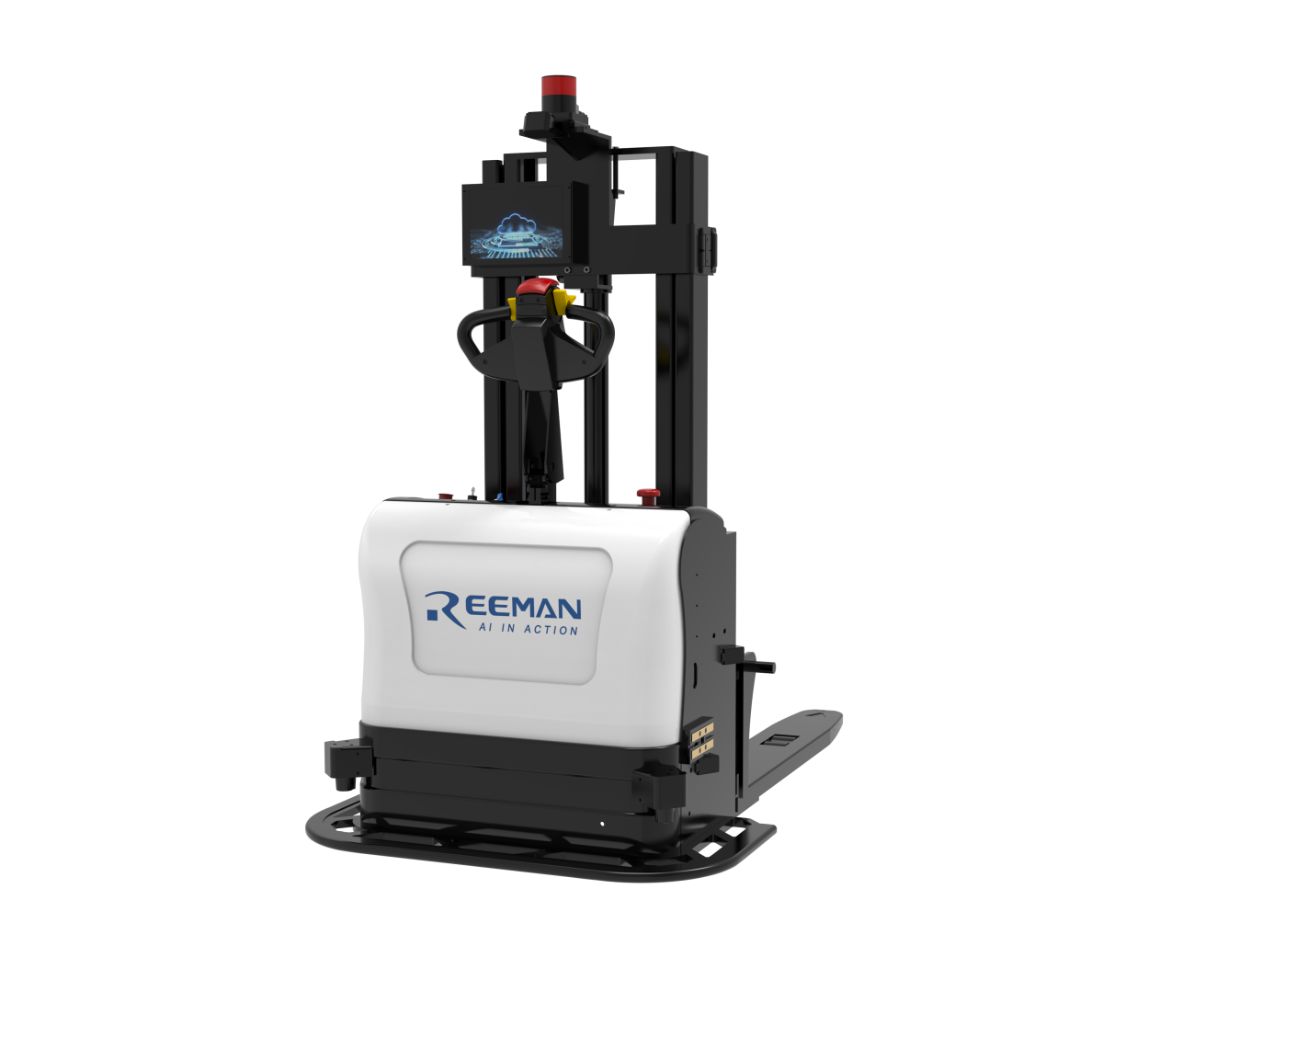

Contents
1.Product Introduction 3
(1) Overview of Robot components 3
(2)Manual control 3
2.Instructions for using the ForkliftNew APP 4
(1) Home and Settings 4
(2)Auto-pick and place mode 7
(3)Manual pick-and-place mode 11
(4) Mission Mode 14
(5) Network Settings 19
(6)Call mode Settings 20
(7)Other task Settings 22
(8)Bezier curve paramters 23
(9)Door control mode Settings 25
(10)Elevator control Settings 28
(11)Version Information 30
Introduction
The ForkliftNew APP is a universal control software for smart forklifts. This manual is a general manual. We reserve the right to modify the ForkliftNew APP. In case of any discrepancy between the manual and the actual situation, the actual situation shall prevail. The manual is for reference only.

1.Product Introduction

(1) Overview of Robot components
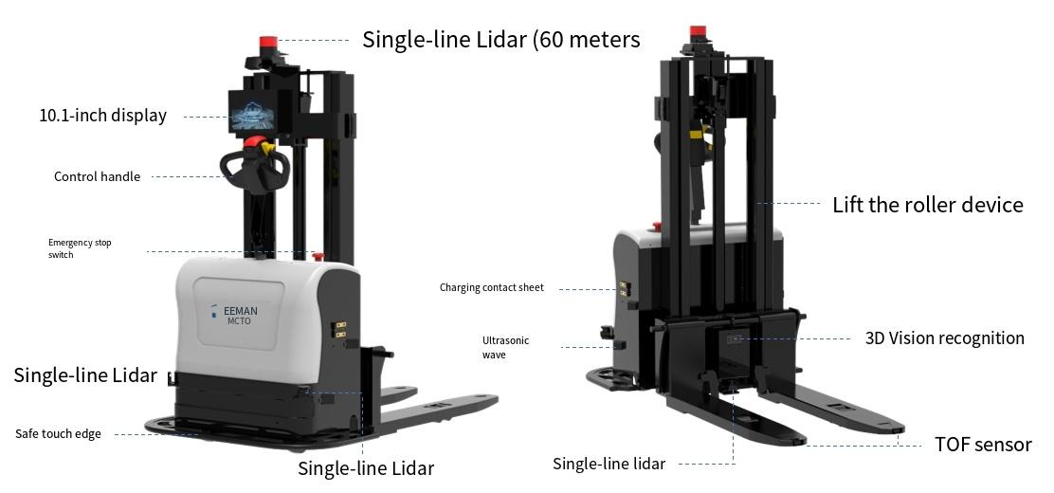

(2)Manual control
- Power on: Turn the key to the right to power on
- Manual/Auto switch knob: Turn left for manual and right for auto
- Handle control:
Unlock the handle:
① Place the magnetic card in the position of the handle button to activate the handle
② After the handle display lights up, press the 7/8/9 button four times and click the green OK button
Forward and backward: The orange push buttons on either side of the red button on the handle, pushing the machine forward makes it move forward and pushing it backward makes it move backward
Up and down: When the yellow button in the middle of the handle is pressed down, it lowers the fork arm; when it rises, it lifts the fork arm

2.Instructions for using the ForkliftNew APP

(1) Home and Settings

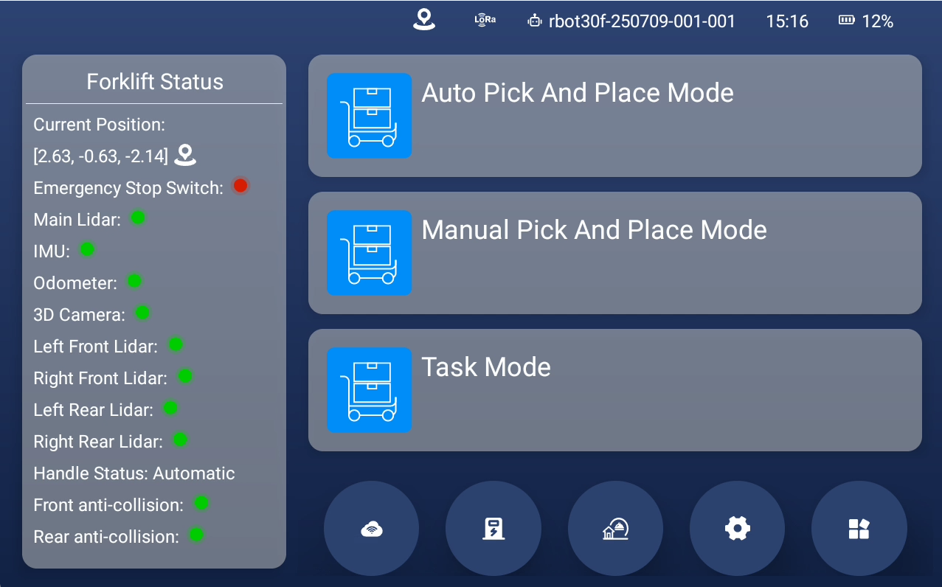
Interface: On the left is machine status, on the upper right is machine code and battery level, on the middle right are various modes that can be swiped down, and on the lower right are function buttons
1.Machine code: rbot30f-250709-001-001, click the code consecutively to exit the APP.
2.Battery level: Shows the current battery level of the machine
3.Forklift status: Shows the current status of each sensor on the machine
4.The various modes in which the machine performs tasks
① Auto Pick And Place Mode
② Manual Pick And Place Mode
③ Task Mode
5.Function buttons: In order WiFi, Return to Charging Station, Return to Production point, Settings, Machine information

- Settings page
Path: forklift APP - Settings Controls
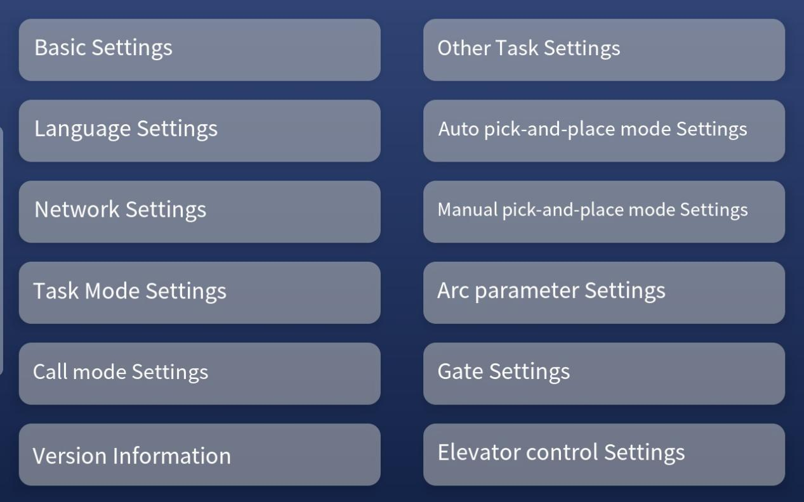

(2)Auto Pick And Place mode
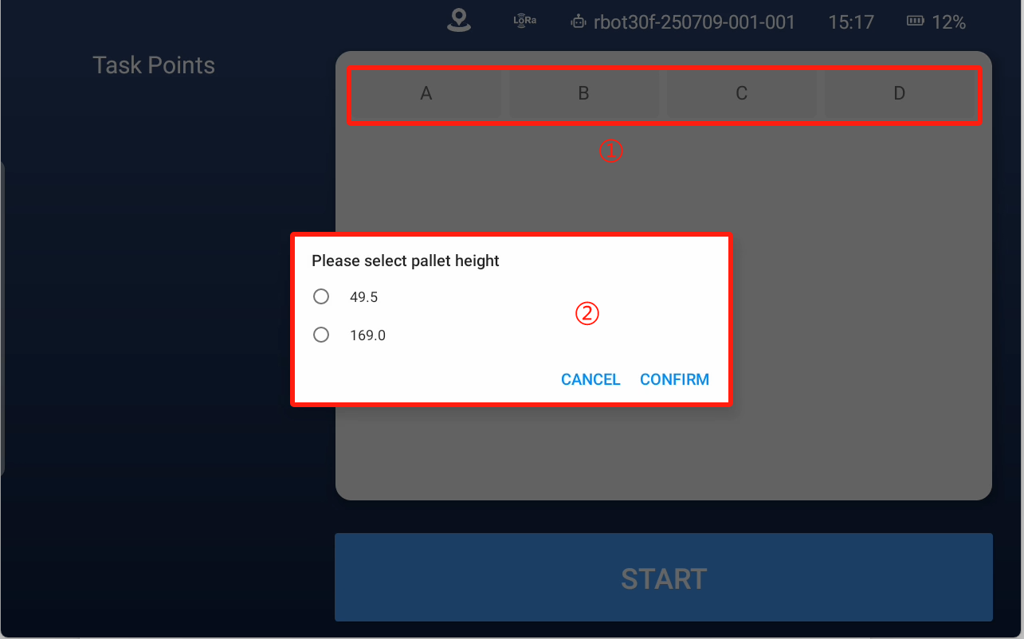
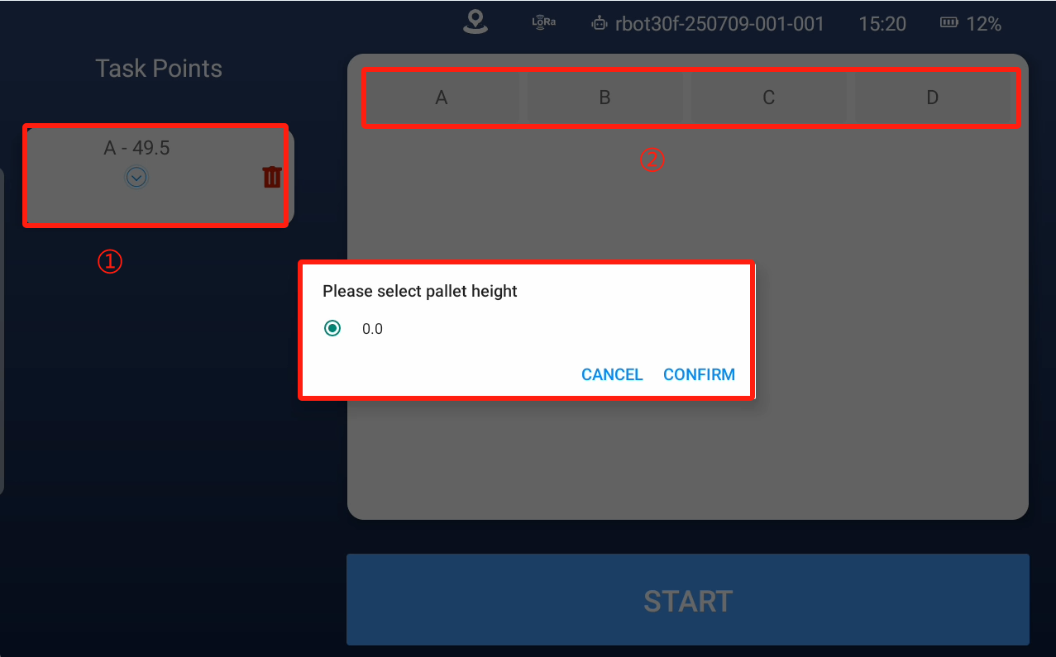
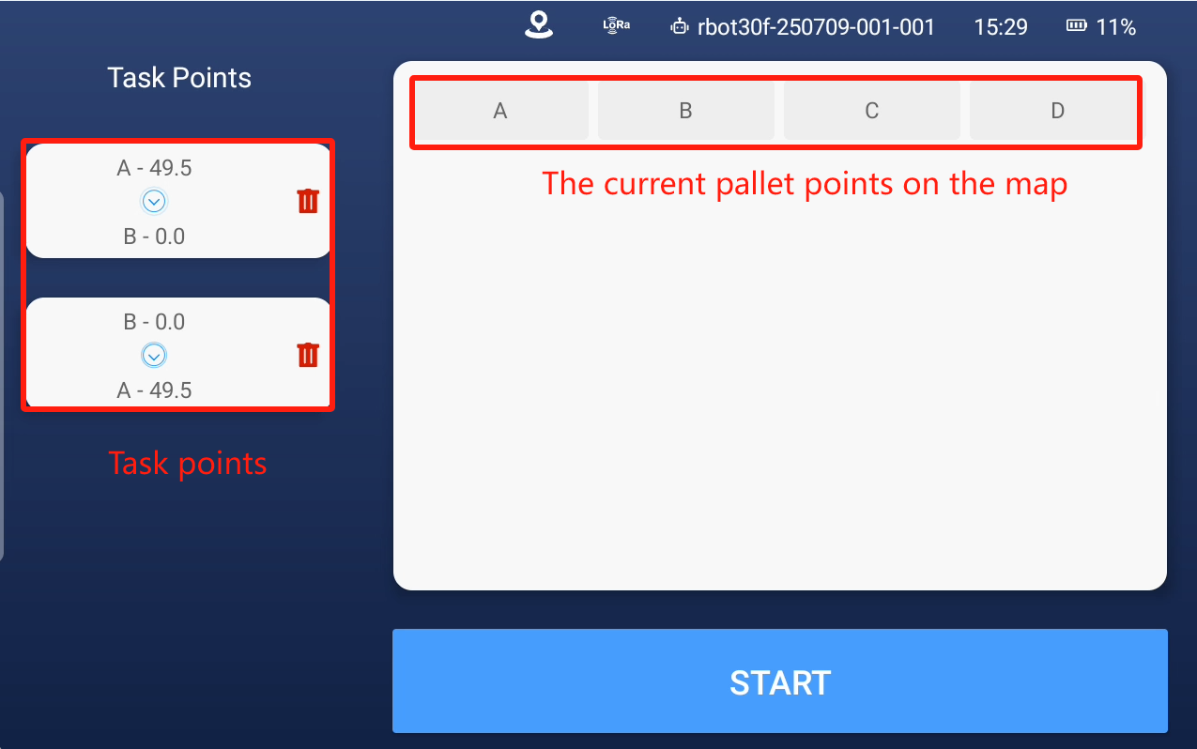
Task Logic: Select pairs of points to perform pick-and-place tasks in sequence. As shown in the figure, two groups of tasks are selected. The machine first goes to A to pick up goods and places them in B, then to A to pick up goods and places them in W. If there is no goods at point A, skip the group and execute B→A. If goods are picked up at point A and point B is occupied, the task fails.

- Point locations: All the card point locations in the current map are displayed on the right side
- Set tasks: Select two pallet points in sequence as a set of pick-and-place tasks, such as A→B for the machine to pick up goods at point A and place them at point B. Tasks can be set in multiple groups
- Swipe right on the left white bar to go back
- Auto-pick and place mode Settings:
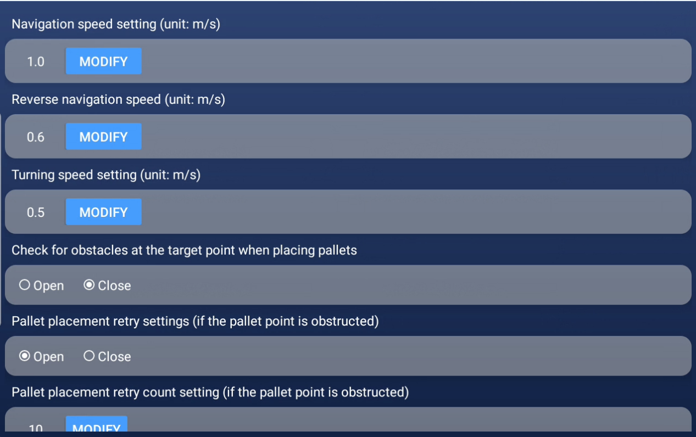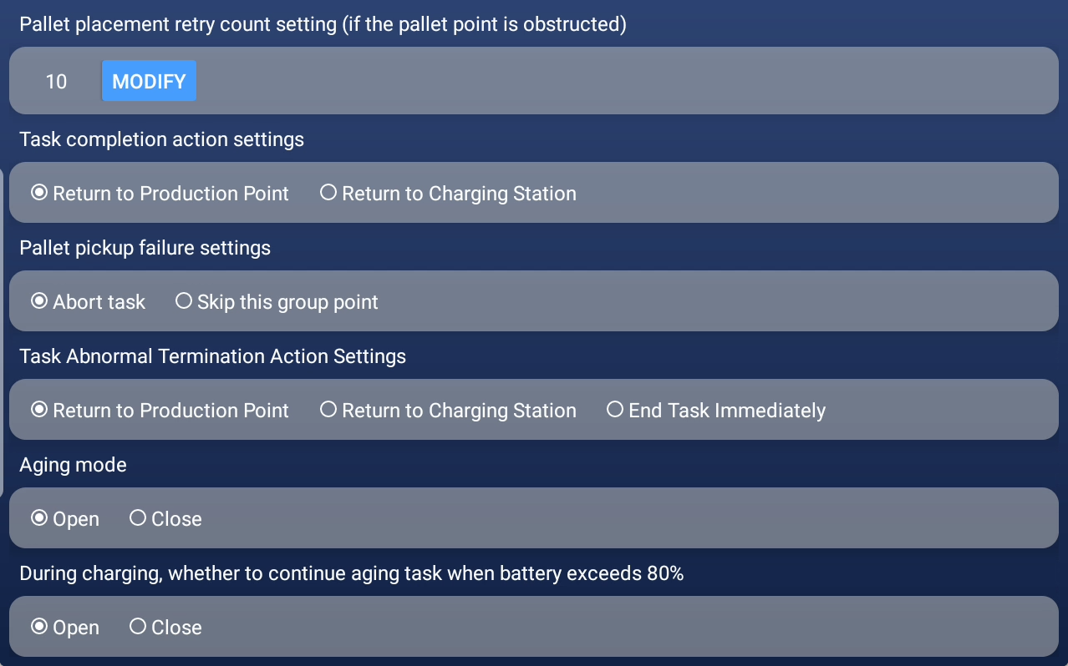
Navigation speed setting: Set the running speed of the machine forward
Reverse navigation speed: Set the running speed of the machine in reverse
Turning speed setting: Set the speed of the machine's fixed-point turning (it is recommended not to exceed 0.3)
Check for obstacles at the target point when placing pallets: When you arrive at the docking point of the card plate, the fork arm will be lowered to identify whether there are obstacles
Pallet placement retry settings: The card plate can be re-detected when it detects an obstacle
Pallet placement retry count setting : Set the number of rechecks
Task completion action settings: Set the standby point after the machine completes the task
Pallet pickup failure settings: when there are multiple groups of tasks, you can end the task or continue to the next group of tasks
Task Abnormal Termination Action Settings: return to the production point, return to the charging pile, and end the task in place
Aging mode: When enabled, the machine will cycle through the assigned tasks

(3)Manual pick-and-place mode
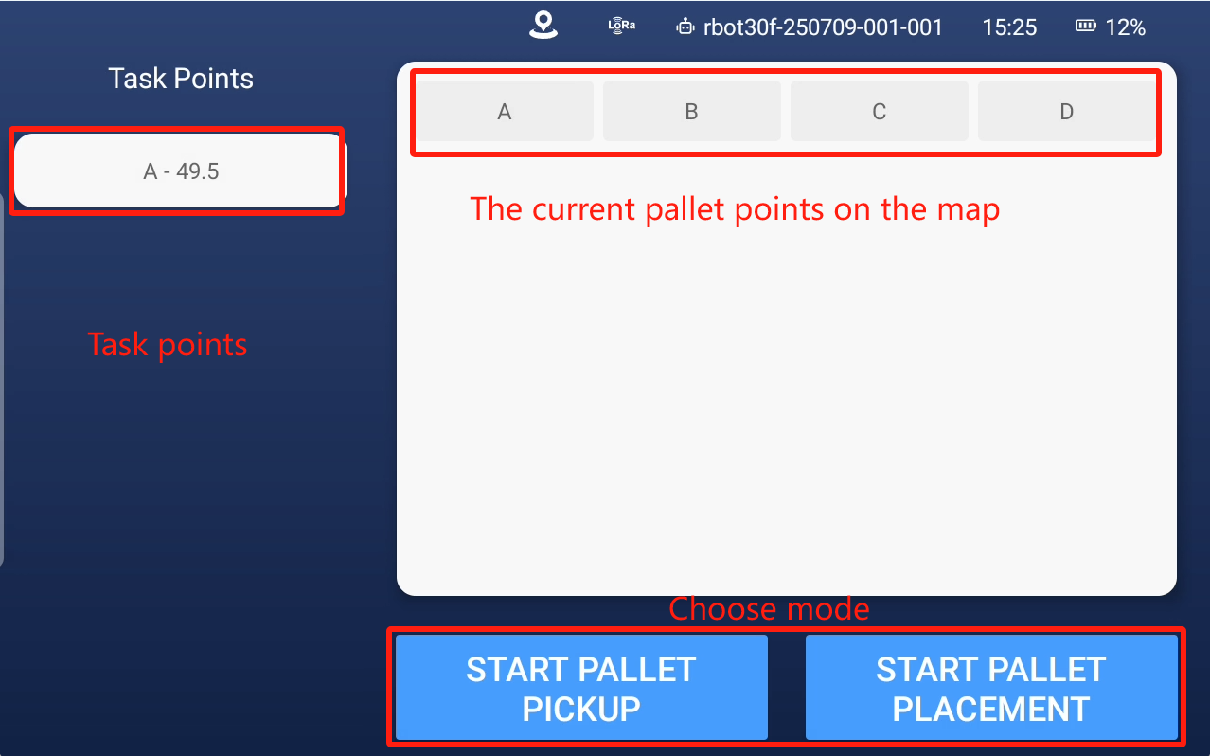
Task Logic: Select a point from the card points on the current map as the target point for the task, and then click Take Card after selecting the point

- Point locations: All the card point locations in the current map are displayed on the right side
- Set the task: Select a point and have the machine perform the task of picking up or placing the card
- Swipe right on the white bar on the left to go back
- Manual pick-and-place mode Settings:

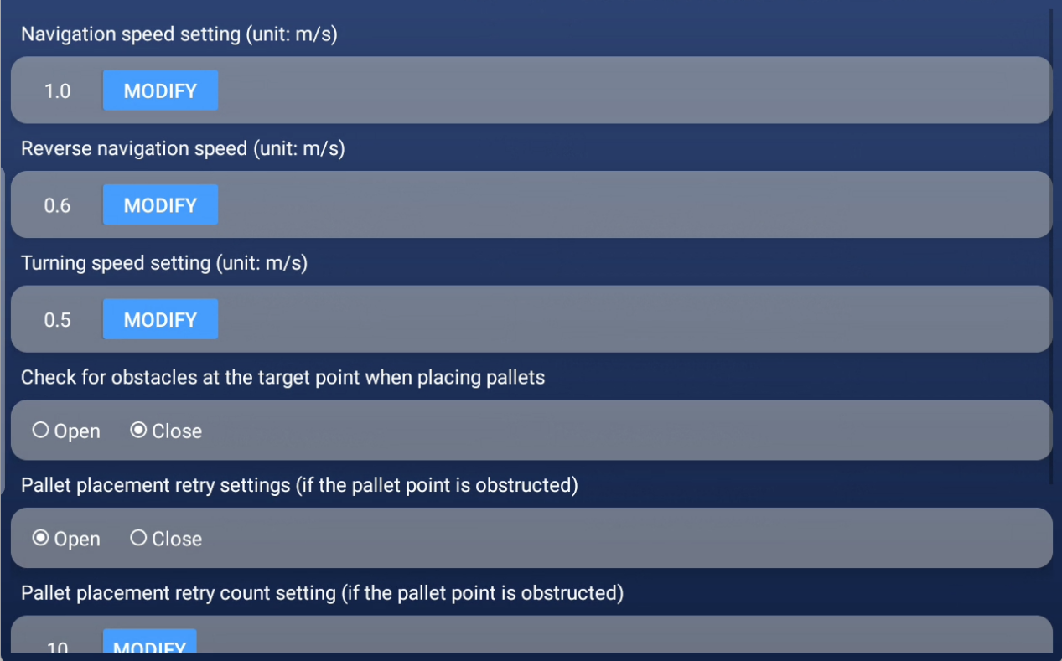
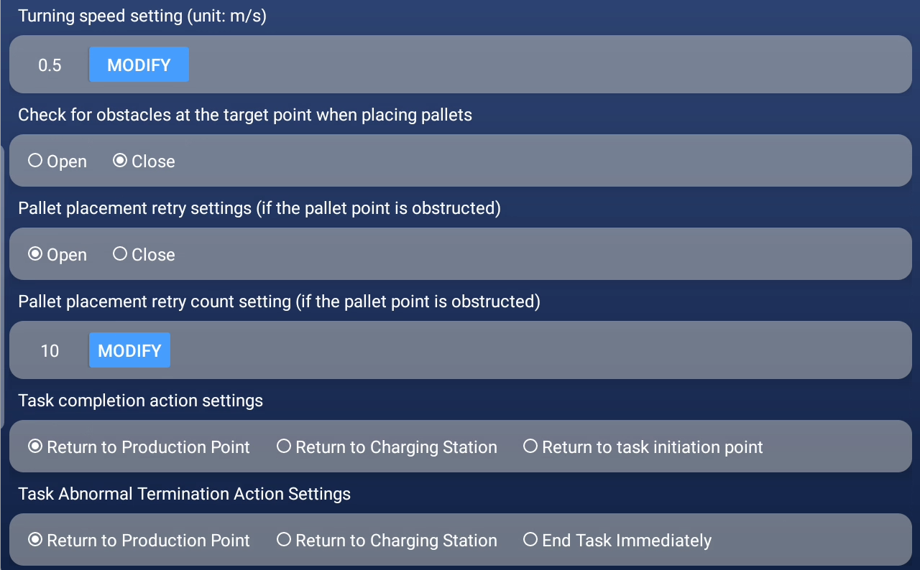
Navigation speed setting: Set the running speed of the machine forward
Reverse navigation reverse speed: Set the running speed of the machine in reverse
Turning speed setting: Set the speed of the machine's fixed turning (it is recommended not to exceed 0.3)
Check for obstacles at the target point when placing pallets: At the docking point of the card plate, the fork arm will be lowered to identify whether there are obstacles
Pallet placement retry settings: The card plate can be re-detected when it detects an obstacle
Pallet placement retry count setting: Set the number of rechecks
Task completion action settings: Set the standby point after the machine completes the task:Return to the production point, Return to the charging pile, Return to task initiation point
Task Abnormal Termination Action Settings:
Return to Production Point:After the mission is terminated abnormally, the forklift returns to the Production Point.
Return to Charging Station:After the mission is terminated abnormally, the forklift returns to the Charging Station.
End Task Immediately:If a task is abnormal, terminate the task immediately.

(4) Mission Mode
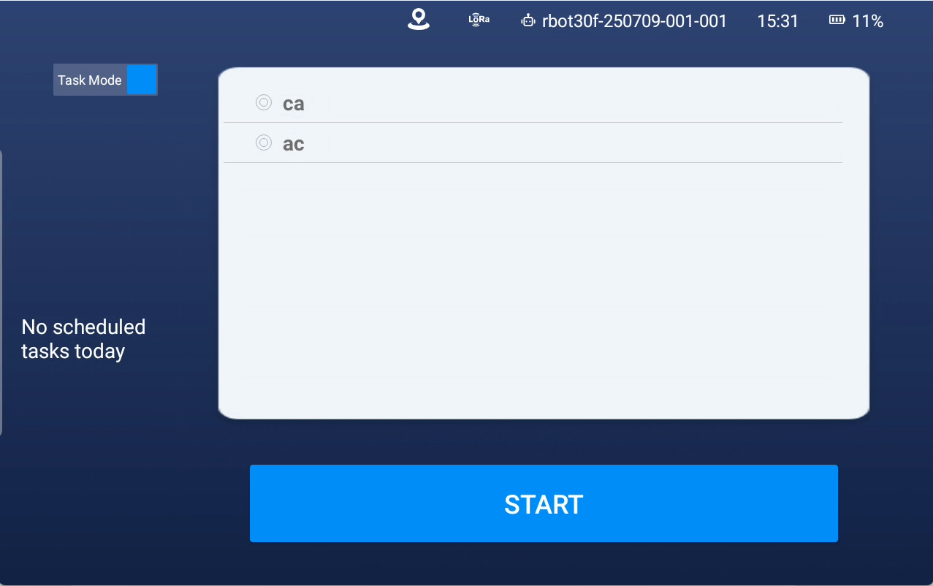
Task Logic: Creating a task can separately set multiple card pick-up points and multiple card pick-up points. The machine will pick up and place the cards in the set order. When picking up a card, if there is no card at the first point, it will go to the next point to pick up the card; if there is no card at the second point, it will go to the third point, and so on. When placing the card, the recognition action can be turned on. At the contact point where the card is placed, the fork arm will be lowered first, and the fork tip laser will identify the placement area for obstacles. If there are obstacles, the next point will be placed, and so on.
- Create task: Click the top left blue button to the left - Click the "+" at the bottom right
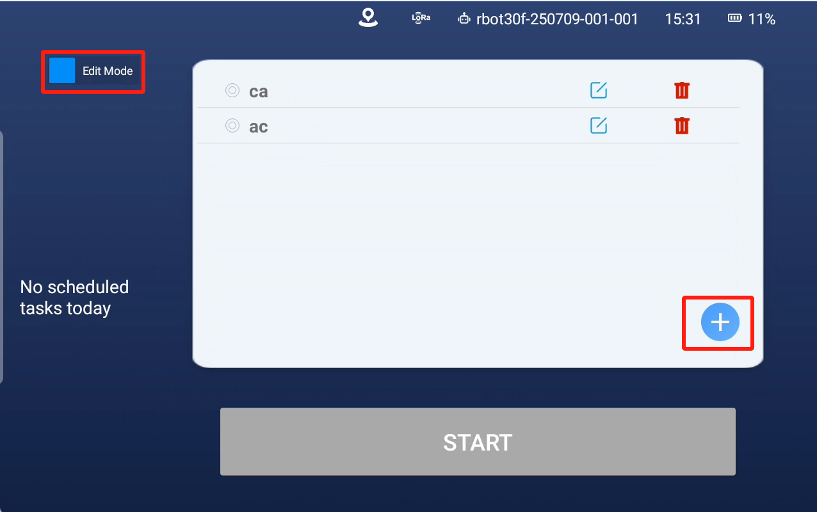
2. Task Settings: You can set them when creating a task or by clicking Edit on the Edit task list
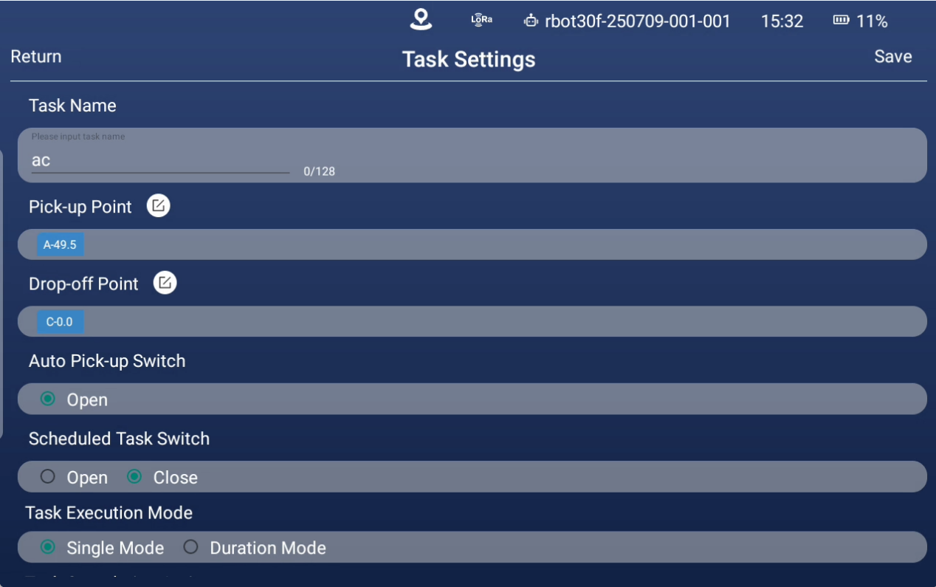
Pick-up Point:

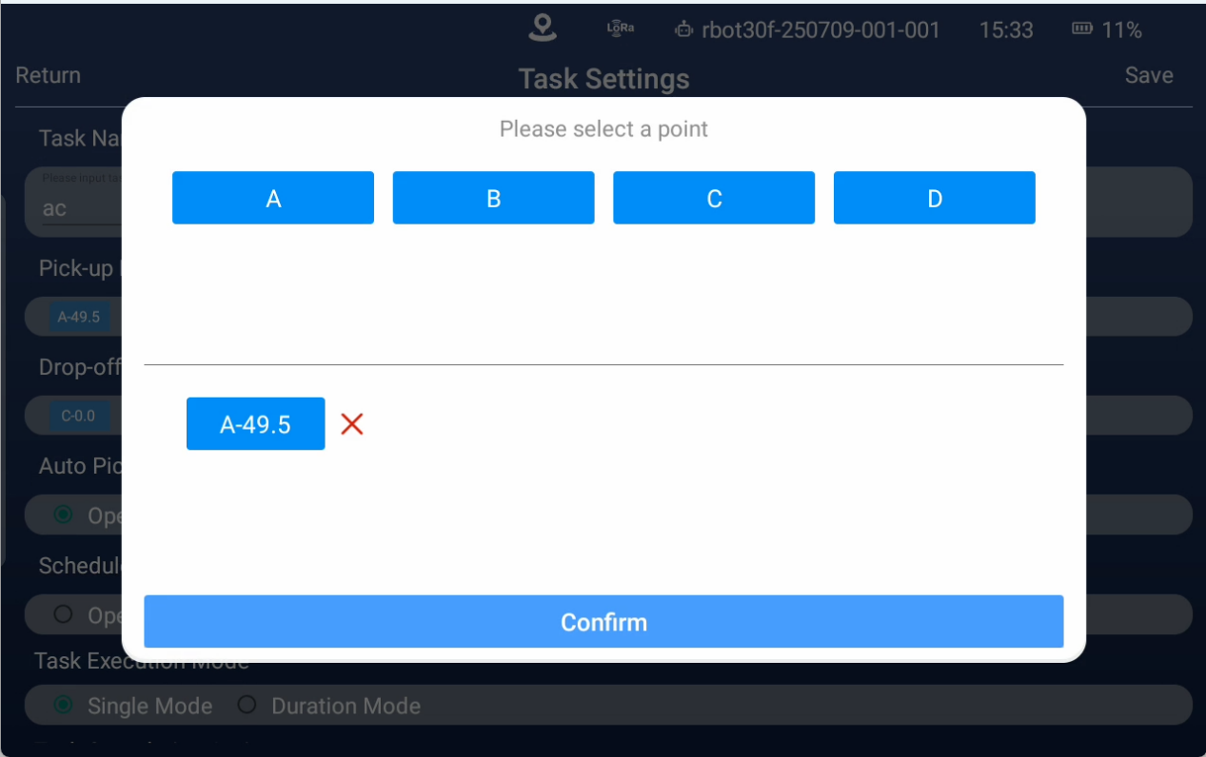
Drop-off point:
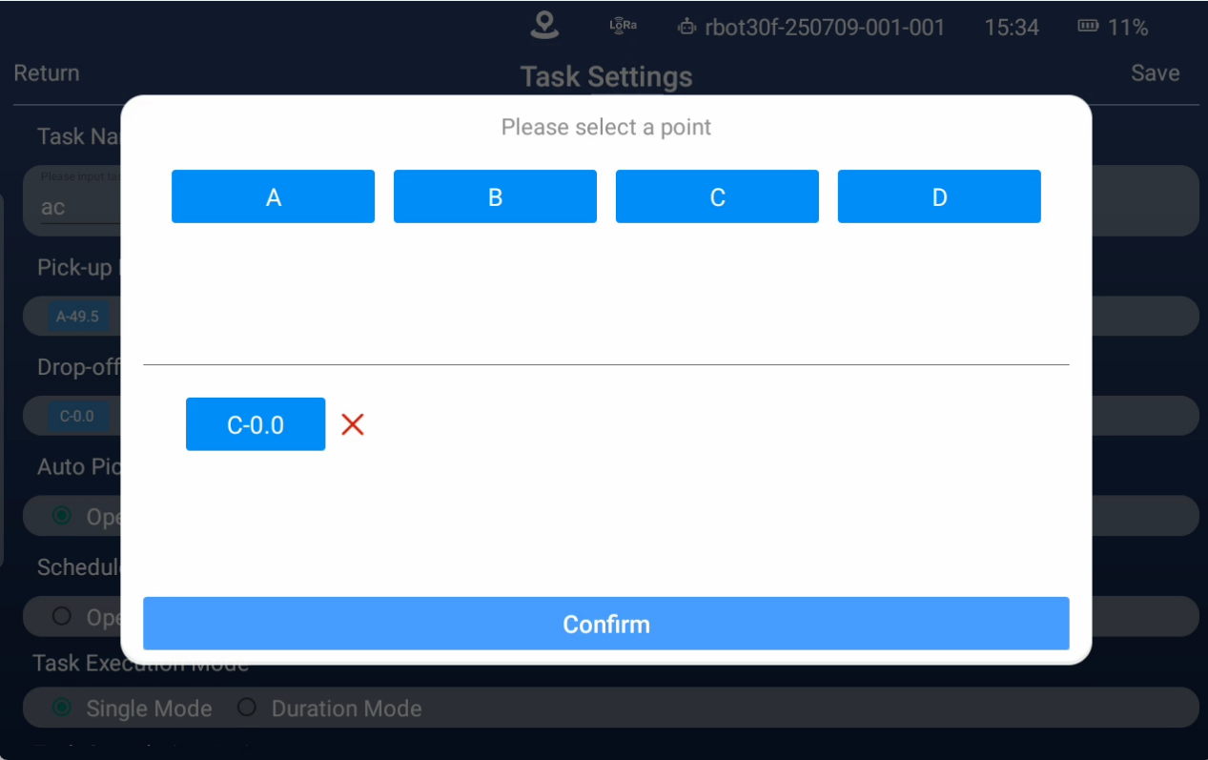

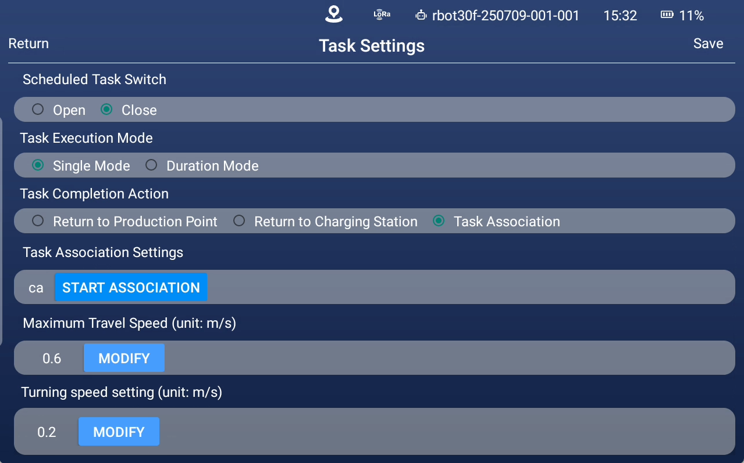
Task name: Set the task name to be displayed in the task list.
Pick-up Point: Set the pickup point of this task. The machine will pick up all the pick-up card points in order. If there is no card at this point, it will continue to the next point. After all the tasks are completed, the task completion action will be executed
Drop-off Point: Set the delivery point of this task. After the machine picks up the goods, it will place them in the order of the delivery point. The task completion action will be executed after the last pallet is placed. If all card plate placement points are occupied, the task will fail abnormally (set in automatic pick-and-place mode).
Auto Pick-up Switch: When opened, the card plate will be automatically forked at the point; when closed, it will stop at the docking point and need to be manually forked (currently not supported to close)
Scheduled Task Switch: You can set the task to be executed at a certain point on a certain day of the week (not available for the time being)
Task execution mode setting:
Single mode: execute all the card plate points in the task, and end the task after completion
Time mode: Set the running time of the machine. If the execution time is not more than the set time, execute again. If the task is not completed and the set time is reached, continue to execute the remaining tasks
Task Completion Action: Set the action to be executed after the machine completes the current task, such as: return to the production point, return to the charging pile, execute related tasks (not available temporarily)
Maximum Travel Speed: The range of walking speed in task mode can be set from 0.3 to 1.6 m/s
Turning speed setting: The turning speed in task mode can be set to range 0.1~1 m/s (it is recommended to set it at 0.5 m/s)
Pan size: Set the dynamic adjustment of tray size to avoid obstacle distance (not available)

(5) Network Settings
Path 1: forkliftnew Home Page -WiFi controls
Path 2: forkliftnew Home Page - Settings Controls - Network Settings
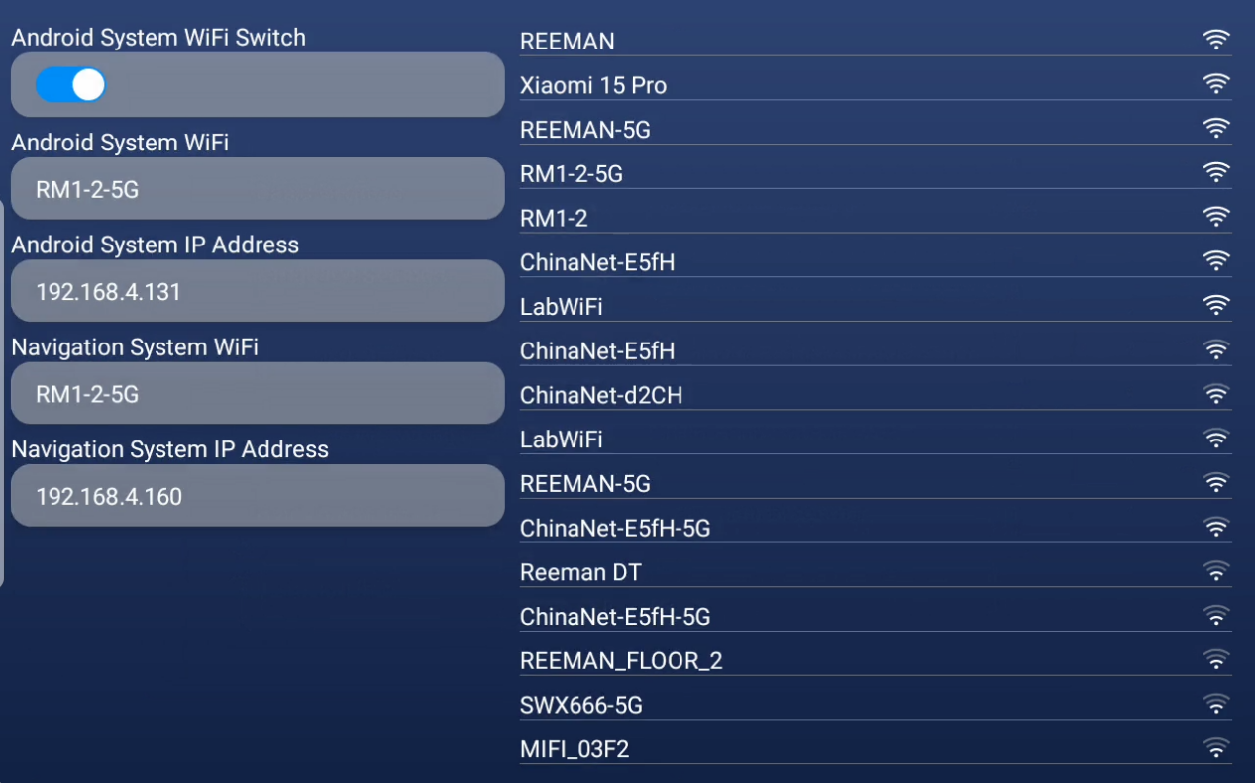
The connected network and IP address are shown on the left side
The currently found Wi-Fi is displayed on the right side
Requirements: Android WiFi and navigation WiFi must be connected to the same network. If remote assistance is required, the network the machine is connected to must be an unencrypted network

(6)Call mode Settings
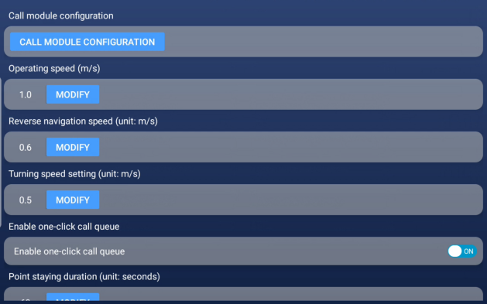
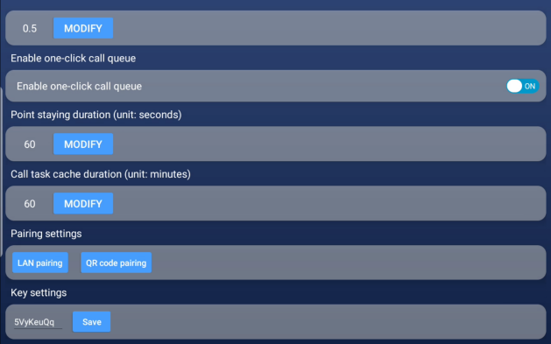
Call module configuration:
Operating speed: Set the running speed of the call mode
Reverse navigation speed setting: Set the running speed of reverse in call mode
Turning speed setting: Set the turning speed in call mode
Enable one-click call queue: After the queue is opened, multiple calls will be queued up and executed in turn.The picture is in closed state.
Point staying duration: Set the time when the call reaches the point. During this time, the machine will not respond to other calls
Call task cache duration: Set the time limit for calling tasks to be queued. The call task will be deleted after timeout
Pairing Settings: Click to select the connection mode between the mobile phone call APP and the machine.You can match via LAN or scan the QR code to bind.
Note: When using the mobile app to call, both the forklift's Android Wi-Fi and the phone need to be connected to the Internet.
Key setting: After modifying the key, all mobile apps connected to the machine will be invalid and need to be reconnected.Normally, it is not recommended to make changes

(7)Other task Settings
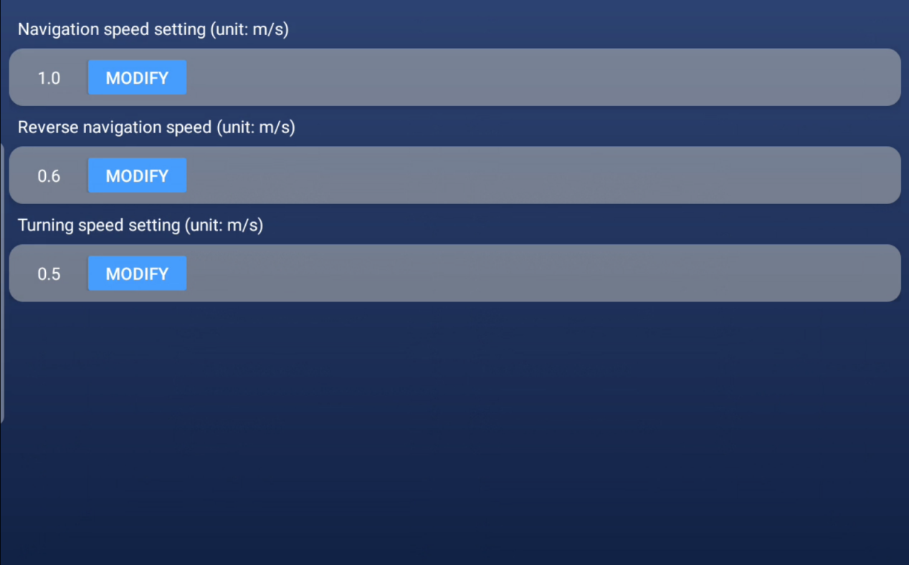
Other tasks refer to the machine completing the task and returning the status of the production point and charging pile
Navigation speed setting: Set the running speed of other modes
Reverse navigation speed: Set the running speed of other modes in reverse
Turning speed setting: Set the speed of turning in other modes

(8)Bezier curve paramters
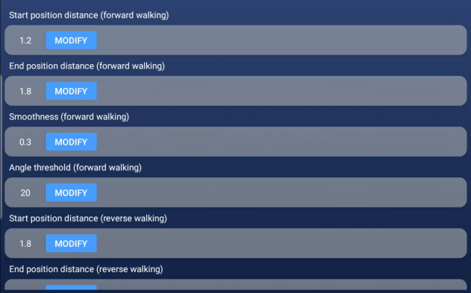
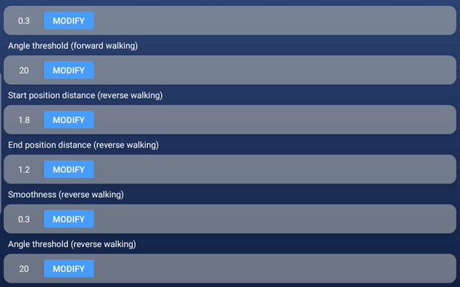
Start position distance(forward walking): Set the distance between the starting point of the machine's forward arc and the turning point
End position distance(forward walking): Set the distance from the forward arc turning point to the end of the machine
Smoothness(forward walking): Set the smoothness of the machine when running in a smooth arc
Angle threshold(forward walking): Set the corner threshold of the machine's forward arc
Start position distance(reverse walking): Set the distance from the starting point of the machine's backward arc to the turning point
End position distance(reverse walking): Set the distance from the forward and backward arc turning point to the end
Smoothness(reverse walking): Set the smoothness of the machine when running backward in an arc
Angle threshold(reverse walking):Set the corner threshold of the machine's backward curve

(9)Door control mode Settings
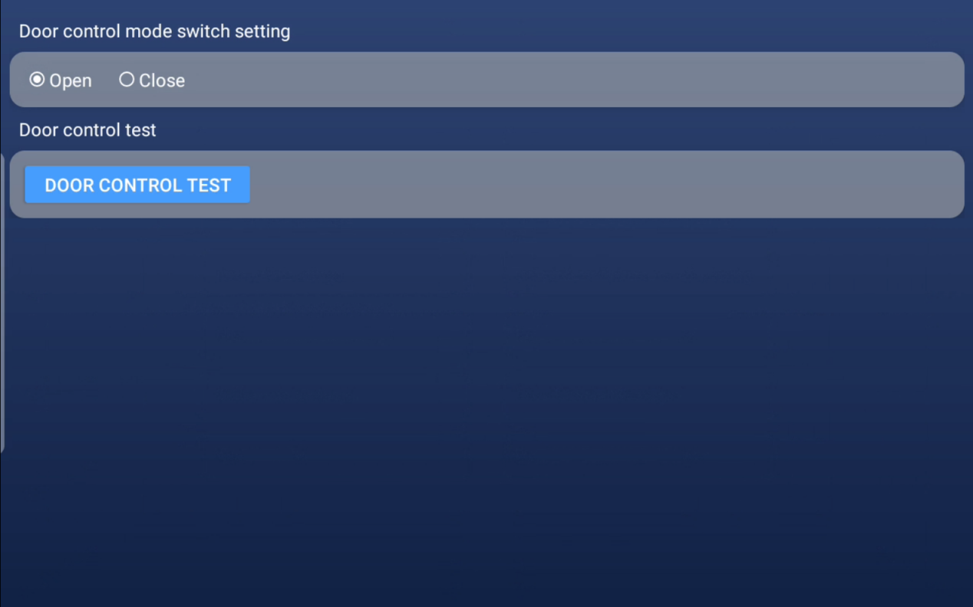
Door control mode switch setting: If there is an automatic door bound, choose open.
Door Control Test: Click on the door control test to enter the following interface:
Step 1: Follow the provided gate configuration documentation to put the gated box into binding mode.
Step 2: Click MODIFY below the image, select a tag code, and click Save.
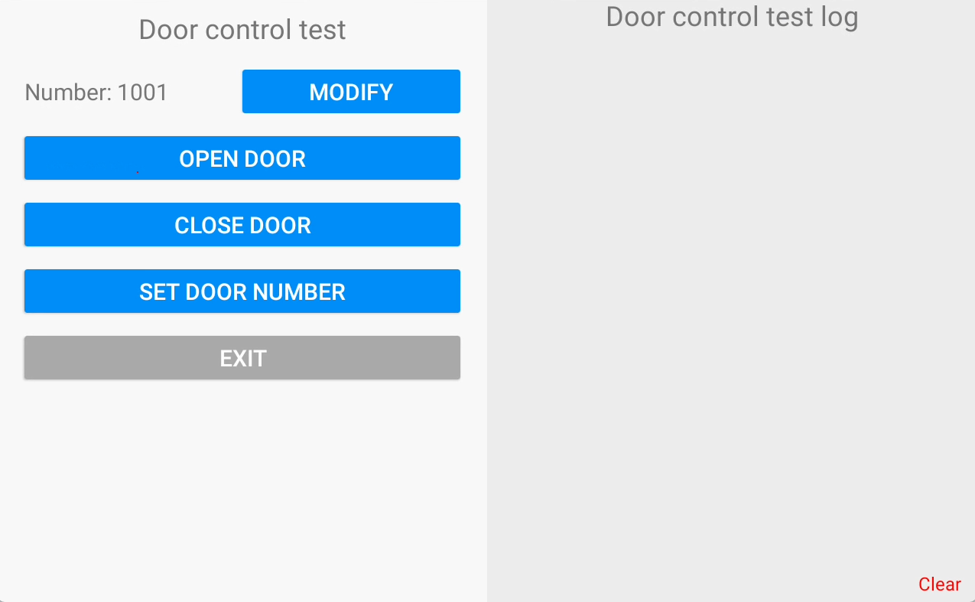
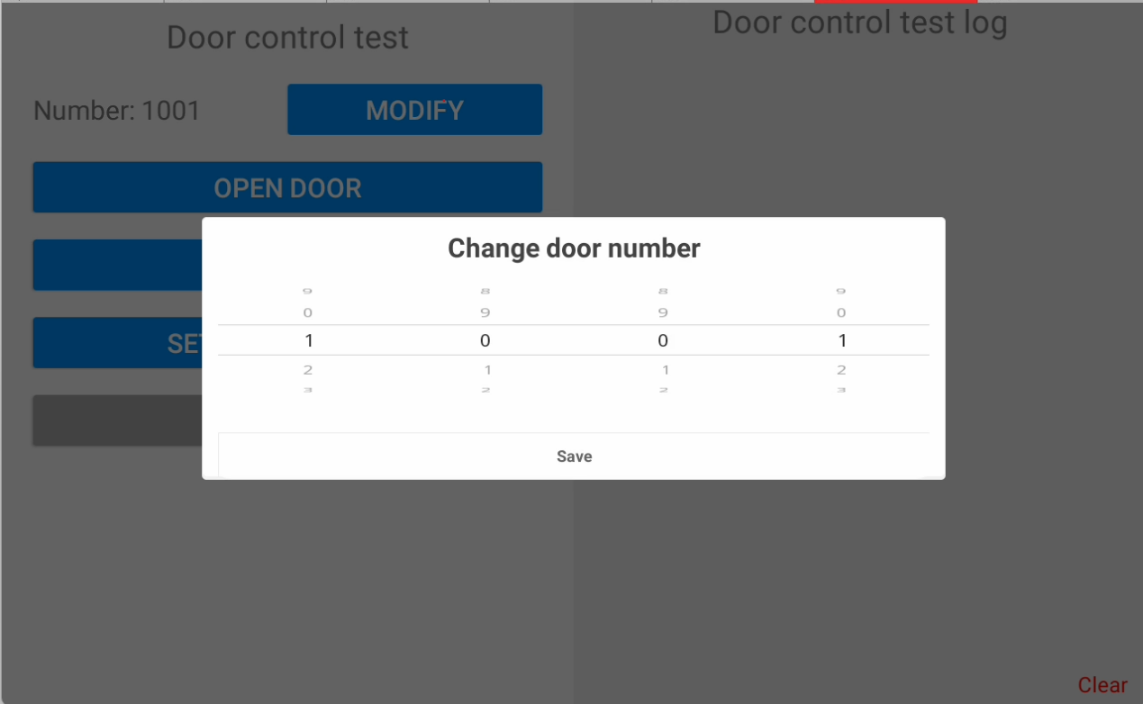
Step 3: Click SET DOOR NUMBER.
Step 4: Click OPEN DOOR or CLOSE DOOR to test.
Door control test log:
Some logs of door settings can be loaded.

(10)Elevator control Settings
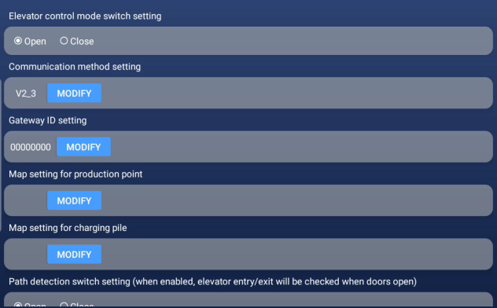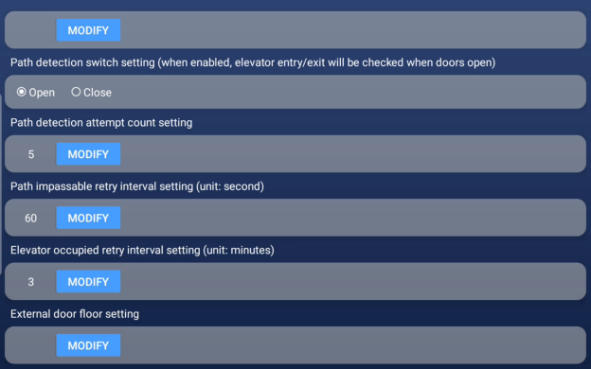
Elevator control mode switch setting: Step control switch button.
Communication method setting: Select the communication mode between the machine and the elevator.
Gateway ID setting:Set the elevator control gateway ID, provided by the technician.
Map setting for production point: Set the floor where the produced point is located
Map setting for charging pile: Set the floor where the charging pile is located
Path detection switch setting: the switch of the detection function in the elevator when entering the ladder
Path detection attempt count setting: Set the number of detections
Path impassable retry interval setting: Set the waiting time for retry after path is blocked
Elevator occupied retry interval setting: Set the waiting time for elevator retry when there is cargo in the elevator
External door floor setting:This is required for floors with different door opening directions

(11)Version Information
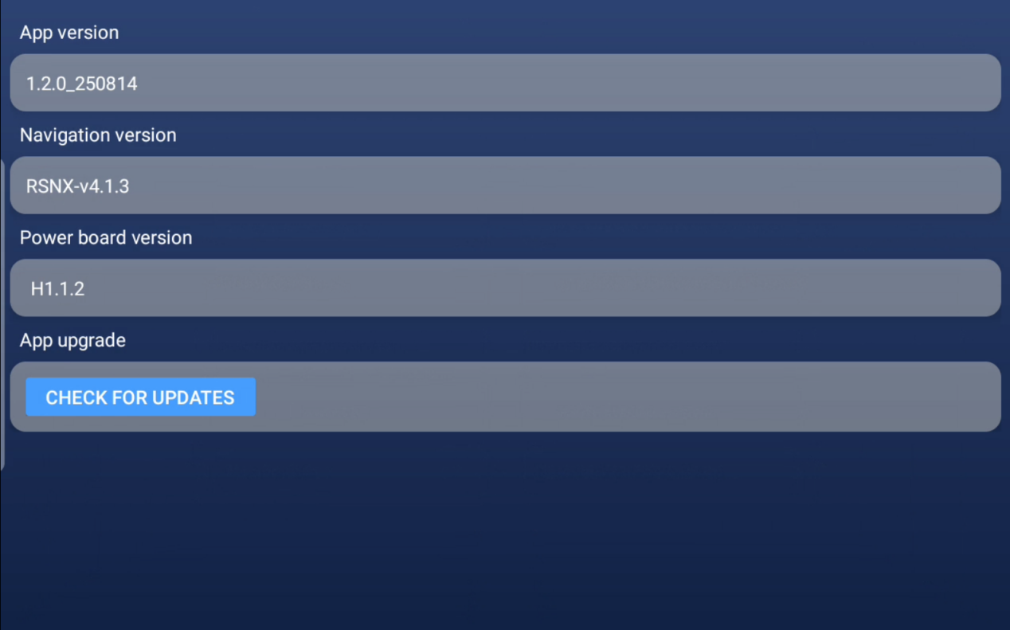
App version: Display the current version of the forkliftnew APP on the machine
Navigation version: Displays the machine's current navigation version
Power board version: Displays the current power board version of the machine
App upgrade: Click to check whether there is a new version available for upgrade. Before upgrading, pay attention to the update content

